- Install git.
Step 1:- Open the official Git website (git-scm.com) and download Git for Windows (64-bit setup)
Step 2:- Run the downloaded installer (.exe file) and click on Next on the license page
Step 3:- Keep the default installation folder and the default components, then click on Next
Step 4:- Select the default editor (for example, Vim or Notepad++) and keep the other options as default
Step 5:- Click on Install and wait for the installation to finish, then click on Finish
Step 6:- Open Git Bash from the Start menu
Step 7:- Check that Git is installed using git --version
Step 8:- Set the username using git config --global user.name "Your Name"
Step 9:- Set the email ID using git config --global user.email "youremail@example.com"
Step 10:- Check the saved settings using git config --global --list

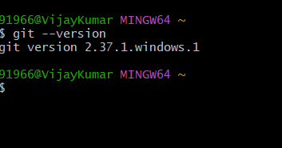

- Create a repo in github with README.md and .ignore file.
Step 1:- Log in to your GitHub account at github.com
Step 2:- Click on the + icon at the top right corner and select New repository
Step 3:- Enter a repository name (for example, my-first-repo) and an optional description
Step 4:- Select Public (anyone can see it) or Private (only you can see it)
Step 5:- Tick the option Add a README file, which creates the README.md file
Step 6:- In the Add .gitignore dropdown, select a template (for example, None or a language like Python), which creates the .gitignore file
Step 7:- Click on Create repository
Step 8:- The repository is created, and both README.md and .gitignore files are visible in the file list
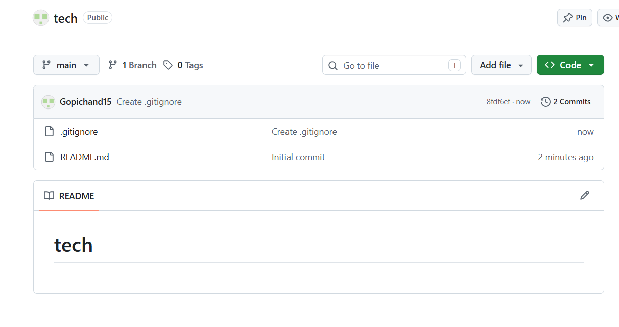

- Clone the created repo to local.
Step 1:- Open the repository in GitHub, click on the green Code button, and copy the HTTPS URL of the repository
Step 2:- Open Git Bash on your local Windows machine
Step 3:- Move to the folder where you want to save the repository using cd <folder-path>
Step 4:- Clone the repository using git clone <repository-URL>
Step 5:- Enter your GitHub username and Personal Access Token if it asks for authentication (needed for a private repository)
Step 6:- Move into the cloned folder using cd <repository-name>
Step 7:- Check that the README.md file is downloaded using ls
Step 8:- Check that the repository is linked to GitHub using git remote -v
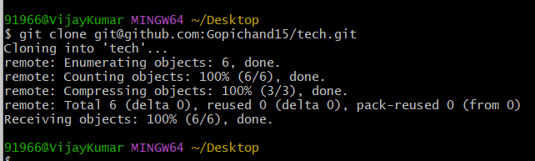
- Create two files in local repo.
Step 1:- Open Git Bash and move into the cloned repository folder using cd <repository-name>
Step 2:- Create the first file using touch file1.txt
Step 3:- Create the second file using touch file2.txt
Step 4:- Check that both files are created using ls
Step 5:- Check the status of the repository using git status, where both files are shown as untracked files
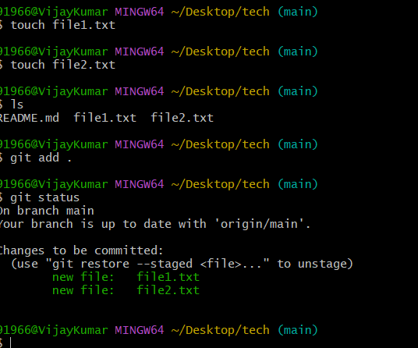

- Commit two files and push to central Repository.
Step 1:- Open Git Bash and move into the local repository folder using cd <repository-name>
Step 2:- Check the status using git status, where file1.txt and file2.txt are shown as untracked files
Step 3:- Add both files to the staging area using git add file1.txt file2.txt (or git add . to add all files)
Step 4:- Commit the files with a message using git commit -m "Added file1 and file2"
Step 5:- Check that the commit is saved using git log --oneline
Step 6:- Push the commit to the central repository (GitHub) using git push origin main
Step 7:- Enter your GitHub username and Personal Access Token if it asks for authentication
Step 8:- Open the repository on GitHub and refresh the page to see both files
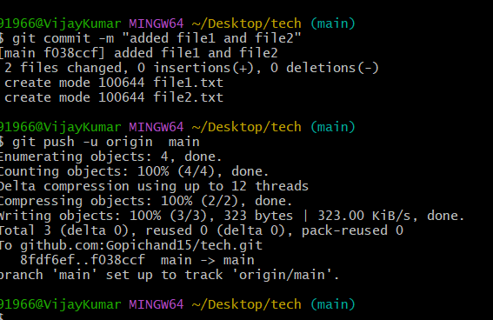

- Create a branch in local and create a sample file and push to central.
Step 1:- Open Git Bash and move into the local repository folder using cd <repository-name>
Step 2:- Create a new branch and switch to it using git checkout -b feature-branch
Step 3:- Check the current branch using git branch, where the active branch is marked with a star
Step 4:- Create a sample file using touch sample.txt
Step 5:- Add the file to the staging area using git add sample.txt
Step 6:- Commit the file with a message using git commit -m "Added sample file in feature branch"
Step 7:- Push the new branch to the central repository using git push origin feature-branch
Step 8:- Enter your GitHub username and Personal Access Token if it asks for authentication
Step 9:- Open the repository on GitHub, select feature-branch from the branch dropdown, and check that sample.txt is visible
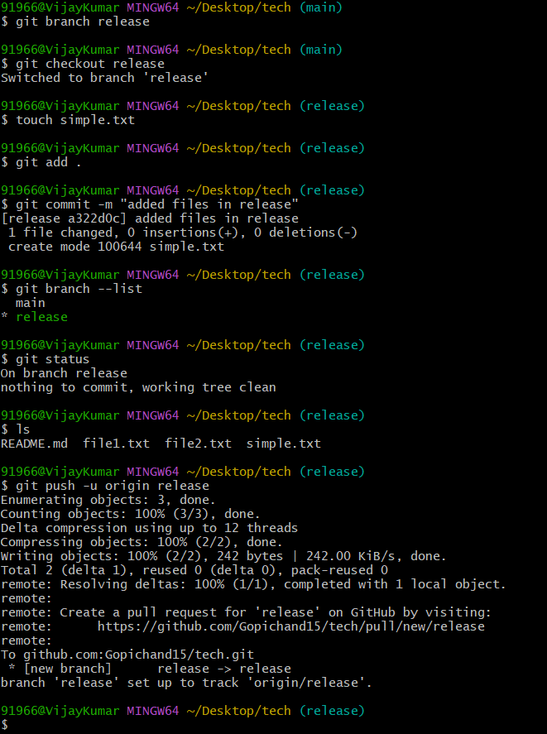

- Create a branch in github and clone that to local.
Step 1:- Log in to your GitHub account and open the repository
Step 2:- Click on the branch dropdown (it shows main) at the top left of the file list
Step 3:- Type a new branch name (for example, feature-branch) in the search box and click on Create branch: feature-branch from main
Step 4:- Click on the green Code button and copy the HTTPS URL of the repository
Step 5:- Open Git Bash on your local Windows machine and move to the folder where you want to save the repository using cd <folder-path>
Step 6:- Clone only that branch using git clone -b feature-branch <repository-URL>
Step 7:- Move into the cloned folder using cd <repository-name>
Step 8:- Check that you are on the new branch using git branch, where feature-branch is marked with a star
Step 9:- Check that the repository is linked to GitHub using git remote -v
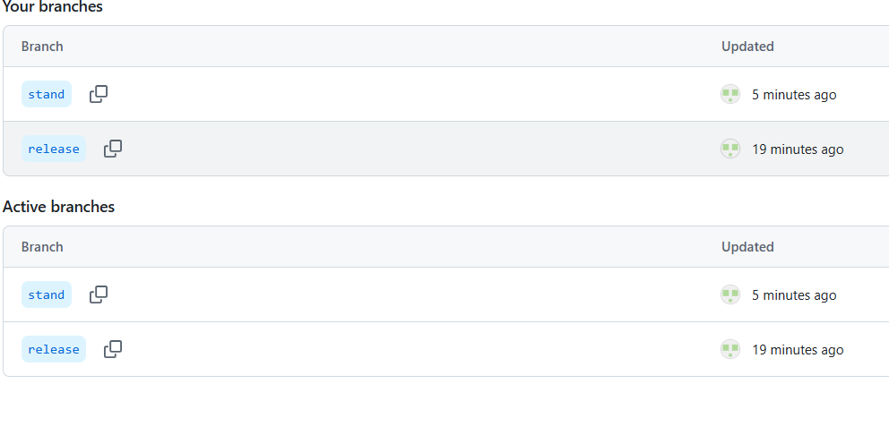
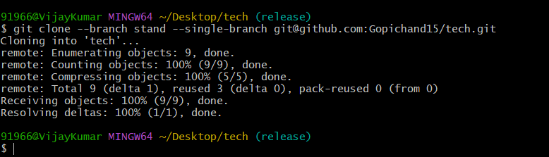

- Merge the created branch with master in git local.
Step 1:- Open Git Bash and move into the local repository folder using cd <repository-name>
Step 2:- Check the available branches using git branch
Step 3:- Switch to the master branch using git checkout master (use main if your default branch is named main)
Step 4:- Merge the created branch into master using git merge feature-branch
Step 5:- If Git shows a merge conflict, open the conflicted file, keep the correct content, then use git add . and git commit -m "Resolved merge conflict"
Step 6:- Check that the files of the branch are now present in master using ls
Step 7:- Check the merge in the history using git log –oneline
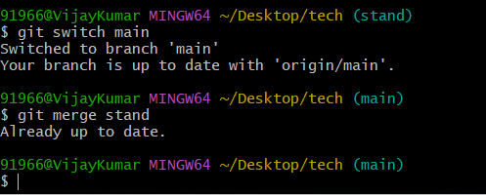

- Merge the created branch with master in github by sending a pull request.
Step 1:- Log in to your GitHub account and open the repository
Step 2:- Make sure the branch (for example, feature-branch) has at least one new commit that is not in master
Step 3:- Click on the Pull requests tab and click on New pull request
Step 4:- Select the base branch as master (the branch to merge into) and the compare branch as feature-branch (the branch with the changes)
Step 5:- Review the changes shown on the page and click on Create pull request
Step 6:- Enter a title and description for the pull request, then click on Create pull request again
Step 7:- Check that GitHub shows “This branch has no conflicts with the base branch”
Step 8:- Click on Merge pull request, then click on Confirm merge
Step 9:- Click on Delete branch if the branch is no longer needed
Step 10:- Open the master branch and check that the files of feature-branch are now present

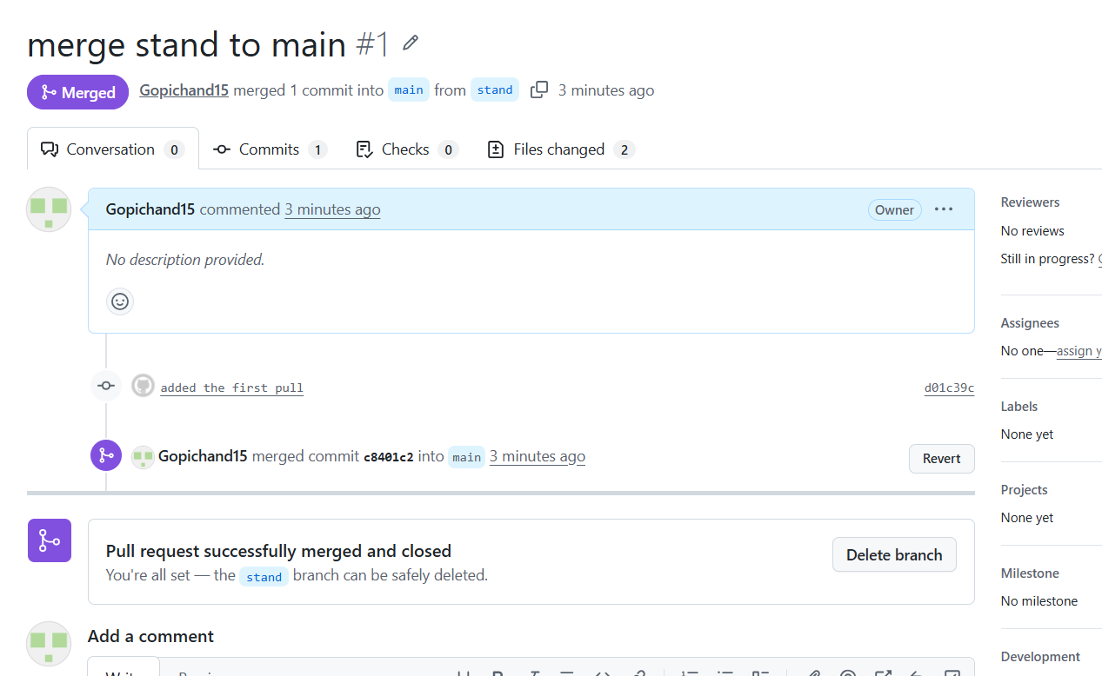

- Create a file in local and send that to branch in github.
Step 1:- Open Git Bash and move into the local repository folder using cd <repository-name>
Step 2:- Switch to the branch where the file should be sent using git checkout feature-branch (use git checkout -b feature-branch if the branch does not exist yet)
Step 3:- Check the current branch using git branch, where the active branch is marked with a star
Step 4:- Create a file using touch newfile.txt
Step 5:- Add the file to the staging area using git add newfile.txt
Step 6:- Commit the file with a message using git commit -m "Added newfile in feature-branch"
Step 7:- Push the file to the branch in GitHub using git push origin feature-branch
Step 8:- Enter your GitHub username and Personal Access Token if it asks for authentication
Step 9:- Open the repository on GitHub, select feature-branch from the branch dropdown, and check that newfile.txt is visible

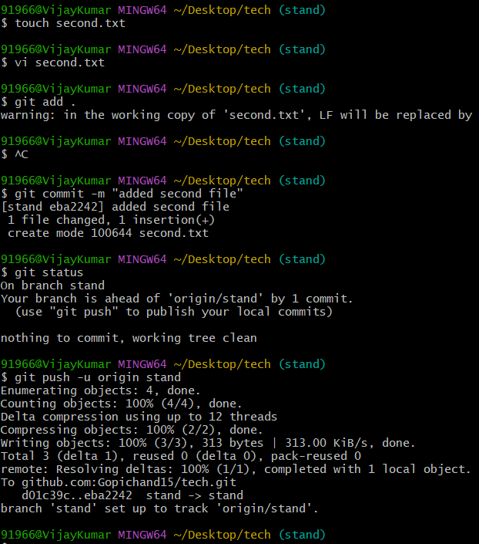
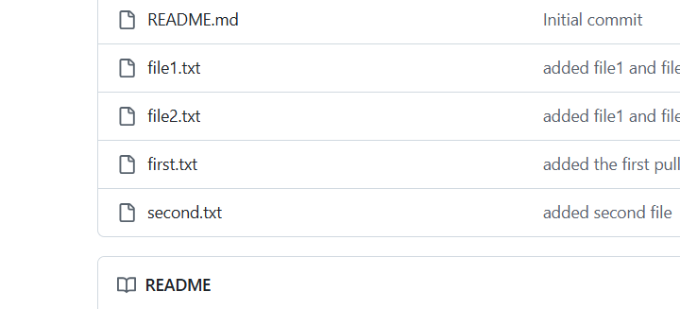
- Clone only a branch from github to local.
Step 1:- Log in to your GitHub account and open the repository
Step 2:- Click on the branch dropdown (it shows main) at the top left of the file list
Step 3:- Type a new branch name (for example, feature-branch) in the search box and click on Create branch: feature-branch from main
Step 4:- Click on the green Code button and copy the HTTPS URL of the repository
Step 5:- Open Git Bash on your local Windows machine and move to the folder where you want to save the repository using cd <folder-path>
Step 6:- Clone only that branch using git clone -b feature-branch <repository-URL>
Step 7:- Move into the cloned folder using cd <repository-name>
Step 8:- Check that you are on the new branch using git branch, where feature-branch is marked with a star
Step 9:- Check that the repository is linked to GitHub using git remote -v
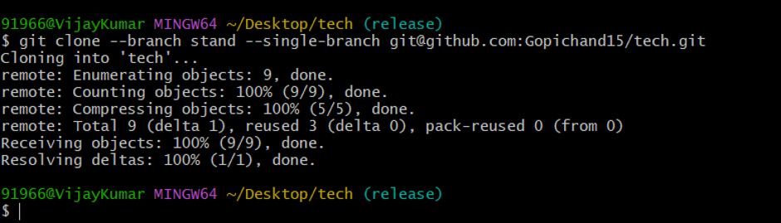

- Create a file with all passwords and make that untrackable with git.
Step 1:- Open Git Bash and move into the local repository folder using cd <repository-name>
Step 2:- Create the password file using touch passwords.txt, and add some sample passwords to it using vi passwords.txt
Step 3:- Check the status using git status, where passwords.txt is shown as an untracked file
Step 4:- Create the .gitignore file using touch .gitignore
Step 5:- Open the .gitignore file using vi .gitignore, add the file name passwords.txt in it, then save and exit
Step 6:- Check the status again using git status, where passwords.txt is no longer shown, and only .gitignore is shown as untracked
Step 7:- Add and commit the .gitignore file using git add .gitignore and git commit -m "Added gitignore"
Step 8:- If passwords.txt was already committed earlier, remove it from Git tracking (without deleting it from the folder) using git rm --cached passwords.txt, then commit this change
Step 9:- This way Git ignores the password file, and it will not be added, committed, or pushed to GitHub

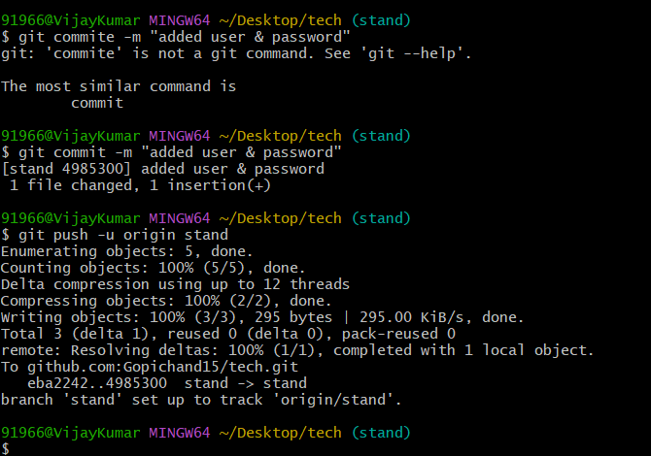
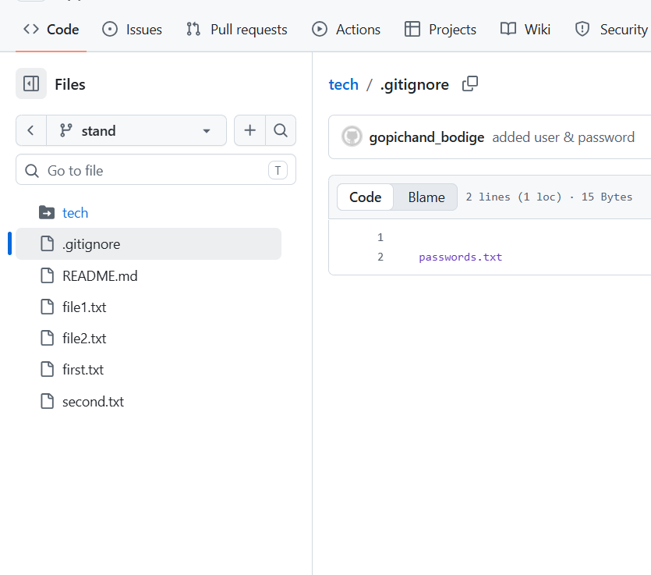
- Make a commit and make that commit reset without savings changes.
Step 1:- Open Git Bash and move into the local repository folder using cd <repository-name>
Step 2:- Create a file using touch resetfile.txt
Step 3:- Add the file to the staging area using git add resetfile.txt
Step 4:- Commit the file with a message using git commit -m "Added resetfile"
Step 5:- Check that the commit is saved using git log --oneline
Step 6:- Reset the last commit without saving the changes using git reset --hard HEAD~1
Step 7:- Check the history again using git log --oneline, where the last commit is removed
Step 8:- Check that the file is also removed from the folder using ls, and check the status using git status, which shows a clean working tree
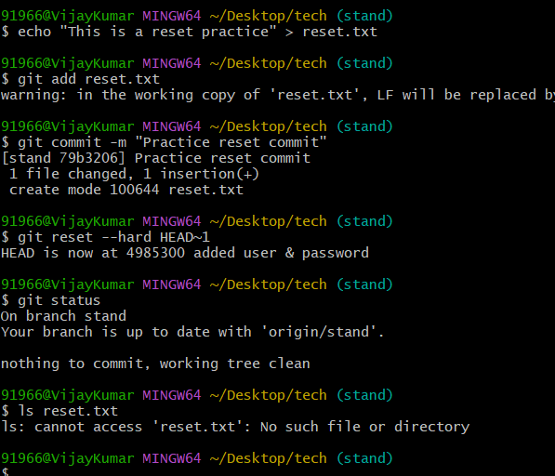

- Revert a commited commit to the older version.
Step 1:- Open Git Bash and move into the local repository folder using cd <repository-name>
Step 2:- Create a file using touch revertfile.txt, add it using git add revertfile.txt, and commit it using git commit -m "Added revertfile"
Step 3:- Check the commit history using git log --oneline and copy the commit ID of the commit that should be reverted
Step 4:- Revert that commit using git revert <commit-ID>
Step 5:- Save and exit the commit message editor that opens (in vi, press Esc, type :wq and press Enter), or use git revert <commit-ID> --no-edit to skip the editor
Step 6:- Check the history again using git log --oneline, where a new revert commit is added on top
Step 7:- Check that the changes of that commit are removed using ls, where revertfile.txt is no longer present
Step 8:- If the commit was already pushed, push the revert commit to GitHub using git push origin main

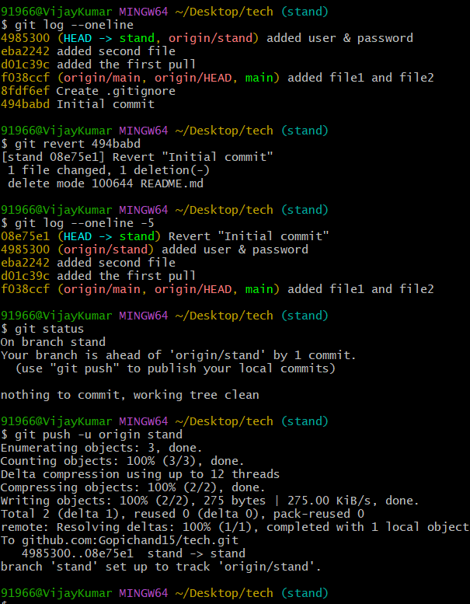
- Push a file to stash without savings the changes and work on another file.
Step 1:- Open Git Bash and move into the local repository folder using cd <repository-name>
Step 2:- Make a change in an existing tracked file, for example echo "work in progress" >> file1.txt
Step 3:- Check the status using git status, where file1.txt is shown as modified
Step 4:- Push the uncommitted changes to the stash using git stash push -m "work in progress"
Step 5:- Check the status again using git status, which shows a clean working tree, because the changes are safely stored in the stash
Step 6:- Check the stash list using git stash list
Step 7:- Create another file to work on using touch file3.txt, then add it using git add file3.txt and commit it using git commit -m "Added file3"
Step 8:- Bring back the stashed changes using git stash pop
Step 9:- Check the status using git status, where file1.txt is shown as modified again and the stash is now empty
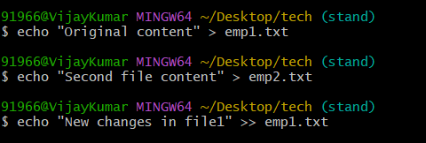
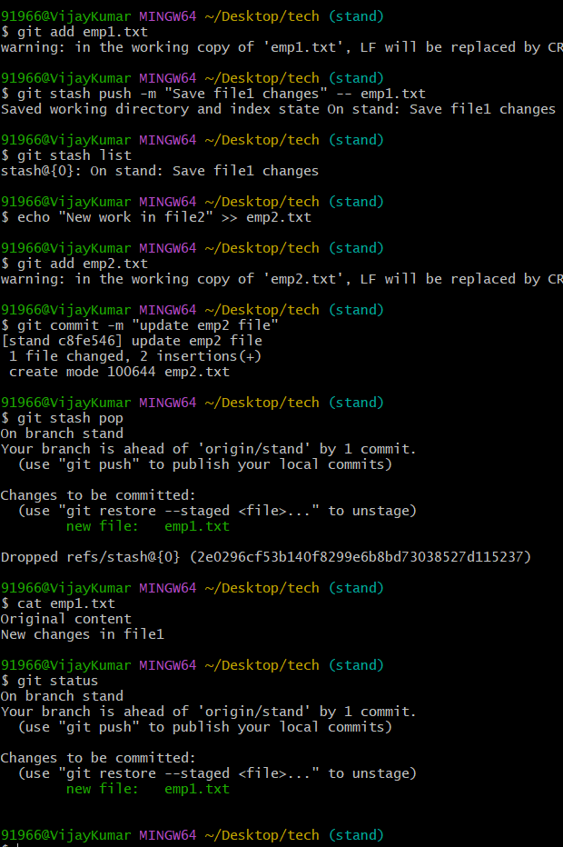

- Undo the stash file and start working on that again.
Step 1:- Open Git Bash and move into the local repository folder using cd <repository-name>
Step 2:- Check the saved stashes using git stash list, where the stash is shown as stash@{0}
Step 3:- Bring back the stashed changes and remove them from the stash using git stash pop
Step 4:- Check the status using git status, where the file is shown as modified again
Step 5:- Check the changes using git diff and confirm that the earlier work is back in the file
Step 6:- Continue working on the file, for example echo "more work" >> file1.txt
Step 7:- Add the file using git add file1.txt and commit it using git commit -m "Completed work on file1"
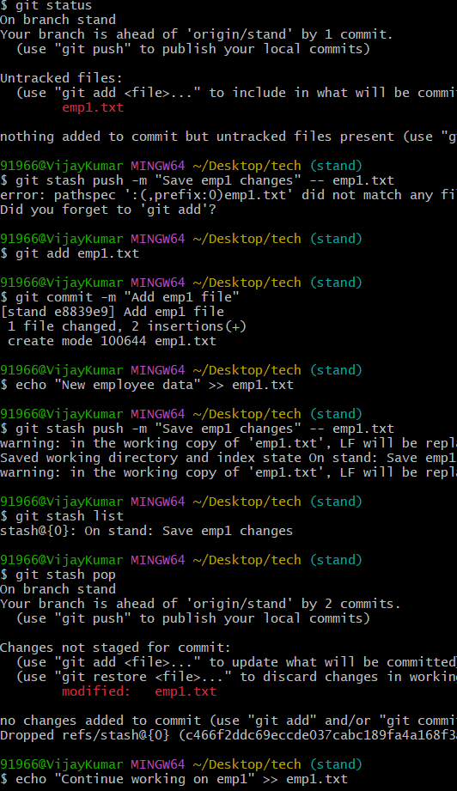

- Generate a ssh-keygen and configure into github.
Step 1:- Open Git Bash on your local Windows machine
Step 2:- Generate the SSH key using ssh-keygen -t ed25519 -C "youremail@example.com" (use ssh-keygen -t rsa -b 4096 -C "youremail@example.com" if ed25519 is not supported)
Step 3:- Press Enter to accept the default file location (~/.ssh/id_ed25519), and press Enter again to skip the passphrase (or type one for extra security)
Step 4:- Check that the keys are created using ls ~/.ssh, where the private key (id_ed25519) and the public key (id_ed25519.pub) are shown
Step 5:- Display the public key using cat ~/.ssh/id_ed25519.pub and copy the full output
Step 6:- Log in to GitHub, click on your profile picture at the top right corner, and select Settings
Step 7:- Click on SSH and GPG keys in the left menu, then click on New SSH key
Step 8:- Enter a title (for example, my-windows-laptop), paste the public key in the Key box, and click on Add SSH key
Step 9:- Test the connection from Git Bash using ssh -T git@github.com, type yes if it asks to continue, and check for the message “Hi username! You’ve successfully authenticated”
Step 10:- To use SSH with a repository, clone it using the SSH URL (git clone git@github.com:username/repository.git), or change an existing repository using git remote set-url origin git@github.com:username/repository.git
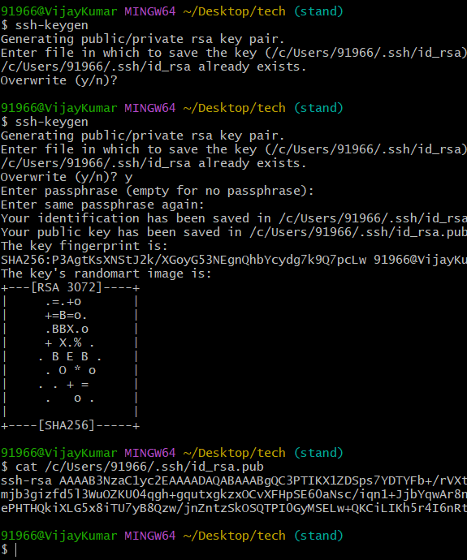
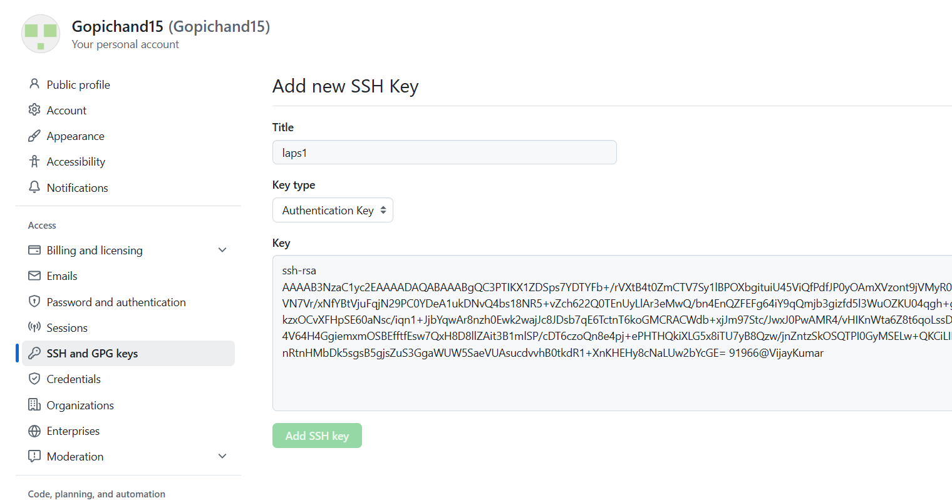

- Configure webhooks to github.
Step 1:- Make sure Jenkins is running on the EC2 server and port 8080 is allowed in the Security Group, so that GitHub can reach it
Step 2:- Install the GitHub plugin in Jenkins from Manage Jenkins > Plugins > Available plugins, then restart Jenkins if asked
Step 3:- Create a Jenkins job (for example, a Freestyle project), select Git under Source Code Management, and enter the GitHub repository URL
Step 4:- In the same job, under Build Triggers, tick GitHub hook trigger for GITScm polling and click on Save
Step 5:- Log in to GitHub, open the repository, and click on Settings
Step 6:- Click on Webhooks in the left menu, then click on Add webhook
Step 7:- In the Payload URL box, enter http://<EC2-public-IP>:8080/github-webhook/ (the slash at the end is required)
Step 8:- Select application/json as the content type
Step 9:- Select Just the push event under “Which events would you like to trigger this webhook?”
Step 10:- Keep Active ticked and click on Add webhook
Step 11:- Check that a green tick appears next to the webhook, which shows GitHub reached Jenkins successfully
Step 12:- Test it by pushing a change to the repository, and check that the Jenkins job starts automatically
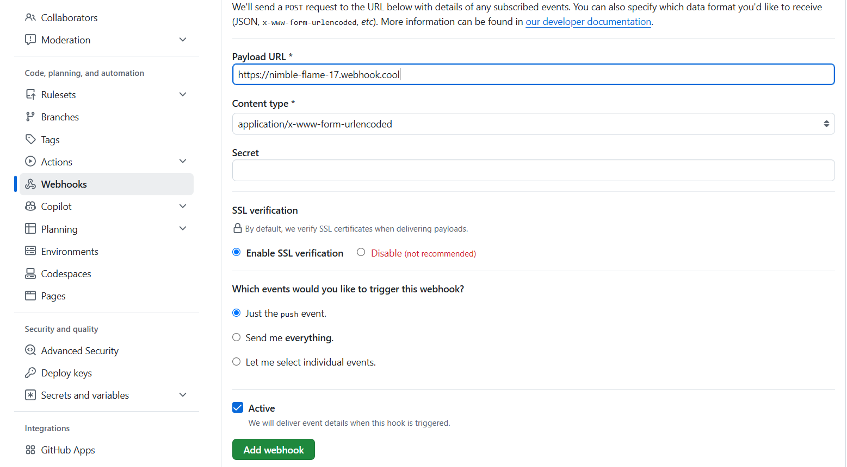
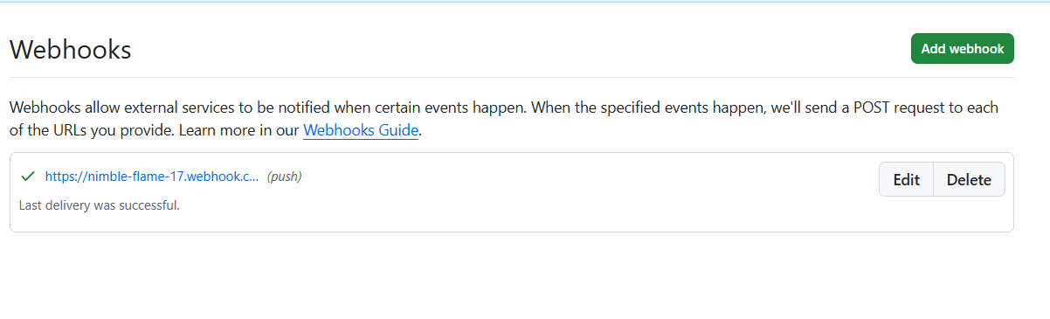

- Basic understanding of .git file.
The .git folder is a hidden repository database created automatically when you initialize Git in a project folder (git init). It functions as the absolute "brain" of your version control, housing all tracking data, configuration settings, and the complete history of your project.
If you delete this folder, your project instantly becomes a normal folder, and your entire version history is wiped out.
The Internal Architecture of .git
Inside the .git folder, you will find specific files and directories that handle everything from tracking changes to running automation:
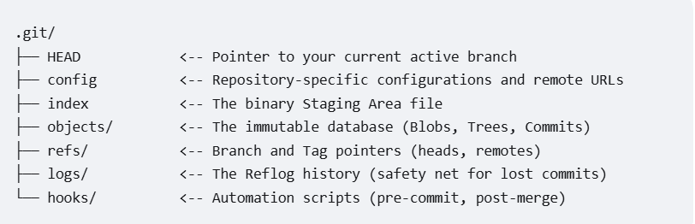

- Check all the logs of git.
Step 1:- Open Git Bash and move into the local repository folder using cd <repository-name>
Step 2:- Check the full commit history using git log, which shows the commit ID, author, date, and message (press q to exit)
Step 3:- Check the history in a short form using git log --oneline, which shows one line per commit
Step 4:- Check the history of all branches in a graph view using git log --oneline --graph --all
Step 5:- Check the last few commits using git log -3, where 3 is the number of commits to show
Step 6:- Check the commits of one author using git log --author="Your Name"
Step 7:- Check the changes made in each commit using git log -p
Step 8:- Check every action done in the repository (commits, resets, checkouts, merges) using git reflog, which is useful to find a lost commit
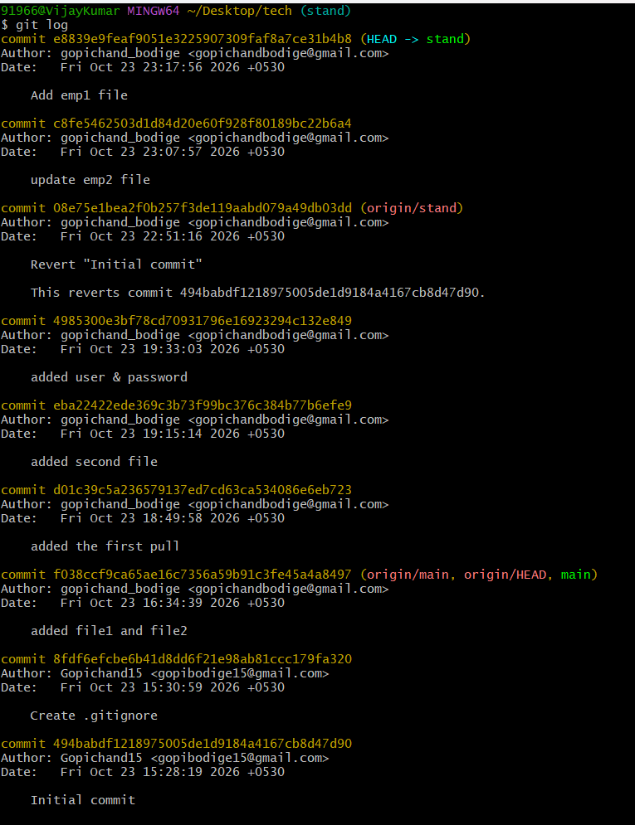

- Rename the commit message.
The user successfully updated their latest commit message to "Updated commit message" using git commit --amend, and then verified the change in their local project timeline by running git log --oneline.
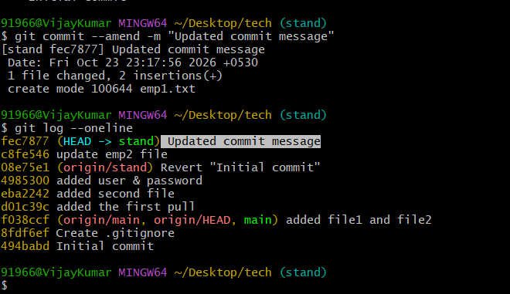

- Merge multiple commits into single commit.
